
RESERVED FOR COVER

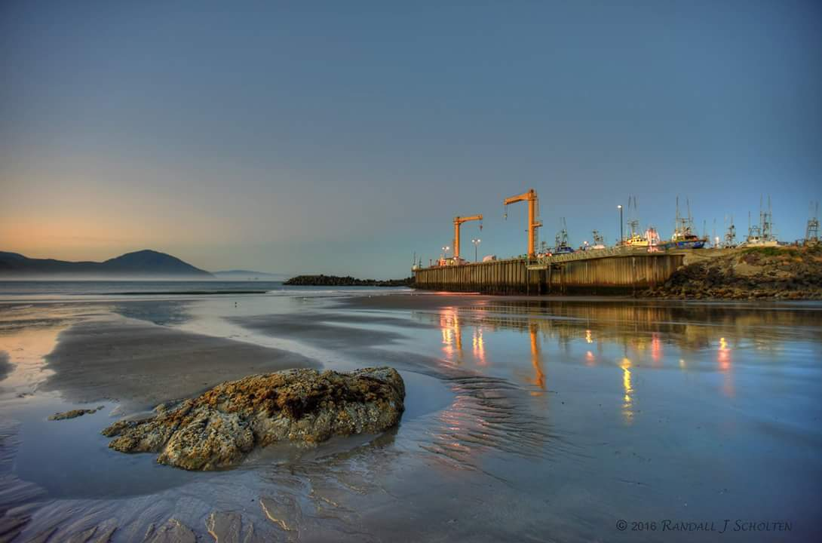

Port of Port Orford
Acknowledgements
This Strategic Business Plan was developed by the Port of Port Orford with assistance from Business Oregon. For more information about the Port of Port Orford, visit:
portofportorford.com

Original Prepared by
BergerABAM
116 Third Street, Suite 217
Hood River Oregon, 97031

In Association with

FCS GROUP
4380 SW Macadam Avenue, Suite 220
Portland Oregon, 97239

Revision Prepared by the
Port of Port Orford Commissioners
Sam Scaffo, President
Tom Calvanese, Vice President
Gary Anderson, Secretary/Treasurer
Brett Webb
David Bassett

Port of Port Orford Staff
Steve Courtier, Manager
Sharlyn Harvey, Office Manager
Ed Schriver, Crane Operator/maintenance
Darrin Faris, Crane Operator/maintenance
Art McMahon, Crane Operator/maintenance
William Ridgeway, Crane Operator/maintenance
Jim Walker, Hydraulic Crane Maintenance

Please see also, Volume 1 – Strategy
February 2016
PORT OF PORT ORFORD
STRATEGIC BUSINESS PLAN

Table of Contents

SECTION PAGE

1.0 Introduction and Strategic PlanNing process 1
2.0 Port History and Mission 1
2.1 History 1
2.2 Mission Statement 3
3.0 Port overview and description 3
3.1 Operating Procedures and Governance 4
3.1.1 Commission 4
3.1.2 Staff 4
3.2 Sites and Facilities 5
3.3 Local and Regional Partners 5
3.3.1 Commercial Fishing Industry 5
3.3.2 City 6
3.3.3 Port Orford Ocean Resource Team 6
3.3.4 Redfish Rocks Community Team 6
3.3.5 Schools 6
3.3.6 Other Organizations 6
4.0 Policy context 7
4.1 Statewide Planning Goals 7
4.1.1 Statewide Planning Goal 9 – Economic Development Error! Bookmark not defined.
4.1.2 Statewide Planning Goal 12 – Transportation 8
4.1.3 Statewide Planning Goal 17 – Coastal Shorelands 8
4.1.4 Statewide Planning Goal 19 – Ocean Resources 9
4.2 Local and Regional Plans 9
4.2.1 City of Port Orford 10
4.2.2 Curry County 10
5.0 Defining the CHALLENGE and opportunity 10
5.1 District Demographic Profile 11
5.2 Community Analysis 12
5.3 District Economic Profile 12
5.4 Economic Strengths and Weaknesses 13
5.4.1 Employment and Jobs 13
5.4.2 Commercial Fishing Fleet Analysis 16
6.0 Situational Analysis 17
7.0 Strategic business plan 18
7.1 Port of Port Orford Priority Projects 18
7.2 Goals and Strategies 24
8.0 Implementation plan 28
8.1 Action Plan 28
8.2 Plan Adoption and Update 28

LIST OF TABLES

Table 1 – Population Trends 11
Table 2 – Population Trends in Oregon and Curry County 12
Table 3 –Non-Farm Employment Trends by Sector in Curry County 14
Table 4 –Curry County Employment Trends by Sector 14
Table 5 –Projected Non-Farm Employment Land Need - 20 year Forecast 16
Table 6 – Historical Seafood Values in Port Orford 16
Table 7 – SWOT Analysis 18
Table 8 – Port of Port Orford Dredging Requirements 20
Table 9 – Priority Projects 24
Table 10 – Capital Improvement Plan 26

LIST OF PHOTOS

Photo 1 – Port Dock – 1888 2
Photo 2 – Port Dock – 1910 2
Photo 3 – Port Dock – 1930s 2
Photo 4 – Port Dock – 1970s 2
Photo 5 – “Let’s Get Dredged” 3
Photo 6 – “Let’s Get Dredged” 5
Photo 7 – Port Facilities 8
Photo 8 – Shoaling of the harbor as seen at minus tide, June 2012 9
Photo 9 – Flooding and damage caused by +30 foot waves, October 2014 21
Photo 10 – The Cannery, 1960s 22

LIST OF FIGURES

Figure 1 –Employment Forecast for South Coast Region, 2010–2020 15
Figure 2 – Rendering by Edoba Design showing redeveloped cannery and commercial/
retail flex space conceptual design. (Source: 2008 Facility Master Plan) 23

APPENDICES

Appendix A – Meeting Summaries
Appendix B – Mission Statement Definitions
Appendix C – Port Facilities Technical Memorandum
Appendix D – Financial Plan
Appendix E – Dredge Operational Analysis Summary
Appendix F – Dredge Financial Analysis
Appendix G – Submersible Pump Dredging Cost Estimate
Appendix H – Cannery Pro Forma Memorandum

Port of Port Orford
Strategic Business Plan

Introduction and Strategic PlanNing process
This Strategic Business Plan is provided to meet the requirements of Business Oregon. This plan and the attached appendices update the 2003 Port of Port Orford Strategic Business Plan and the 2008 Facility Master Plan. This plan was drafted by Port of Port Orford (Port) staff and commissioners with technical review, collaboration and drafting by the consultant team led by BergerABAM. In addition, the development of this plan involved community member input at two public/Port Commission workshops. Summaries of both meetings are included in Appendix A which is available in the Port office.
The public and the Port Commission reviewed the draft updated plan as part of the second round of public meetings in October 2013. Following the October 2013 meeting, the release of the final updated plan was delayed by the State in order to address dredging operational and financial analyses (see section 7.1). Public, Port Commission, and State comments have been incorporated into the final updated on June 2015, Port of Port Orford Strategic Business Plan.
This plan was updated by the Port Commission in November 2016.

Port History and Mission
This chapter gives a brief overview of the Port of Port Orford, the history of the Port and surrounding community, and the Port’s mission statement.

History
The town of Port Orford is located 75 miles north of the California border in Curry County, Oregon. Port Orford was formally founded in 1856 after several years of deadly conflicts between the Qua-to-mah band of the Tututni Indian Tribe and European settlers led by Captain William Tichenor. During the 1880s, Port Orford built its first dock and the Port became the half-way point between Seattle and San Francisco, exporting lumber and importing goods for the local economy0F0F
The Port District of Port Orford was established under Oregon Revised Statutes (ORS) Chapter 777 by popular vote in 1919 and developed as a shipping port for local Port Orford cedar. As seen in photos 1 through 4, the dock was rebuilt several times during the 20th century. The last load of lumber left the Port in 1965 and commercial fishing became the primary industry and has remained so to this day. In 1969, the Army Corps of Engineers (USACE) constructed a breakwater in an attempt to protect the dock from winter storms. An unintended consequence of the breakwater was shoaling of the harbor, leading to emergency congressional action to dredge Port Orford in 1970. Annual Congressional appropriations were necessary to fund dredging operations from 1970 until 2010, when the elimination of earmarks led to the cessation of dredging operations due to lack of funding appropriations.
Today, the Port of Port Orford remains a small fishing port surrounded by a community of fishermen, artists, and individuals with a strong regard for their heritage and the natural beauty of the place they call home. As one of only a few ports worldwide built directly on the ocean and not in an estuary, the Port occupies a distinctive geographic niche that demands specific fishing methods. The Port launches boats by crane and because the crane cannot accommodate larger vessels, the fishing fleet is made up of smaller boats (under 42 feet) that fish by hook and line or traps, primarily during day trips. Selective fishing methods and shorter transport times contribute to added value product. A good deal of the hook and line caught fish is captured and transported live to markets in the San Francisco Bay Area, where it fetches premium prices. The Port relies on the higher prices paid to its commercial fishermen as a source of revenue through a poundage fee imposed on all fish and shellfish delivered at the Port.
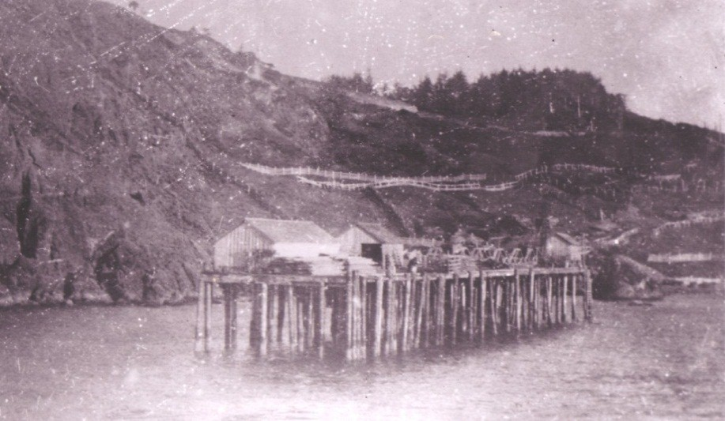
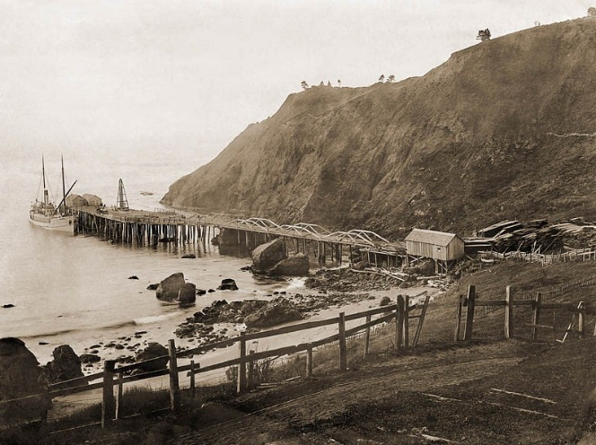
Photo 1 – Port Dock – 1888 Photo 2 – Port Dock – 1910
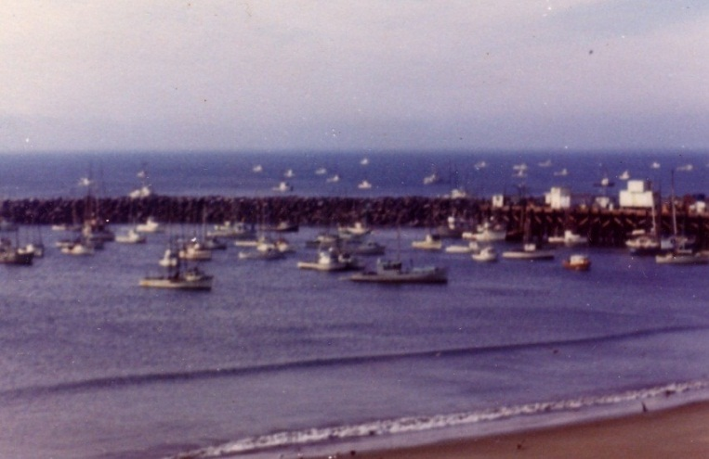
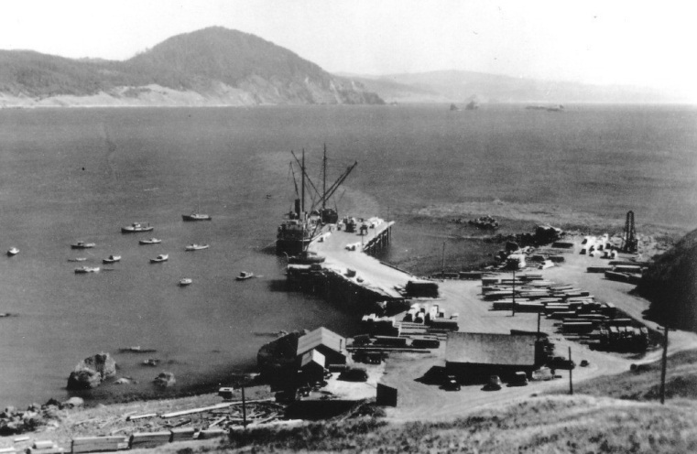
Photo 3 – Port Dock – 1930s Photo 4 – Port Dock – 1970s

Mission Statement
We are stewards of the public trust who:
- Provide ocean access for commerce and recreation.
- Retain current businesses and attract new ones.
- Build our Port’s financial strength.
- Increase and diversify our operating revenues.
- Make the highest and best use of our financial tools, people, and property assets.
- Improve our region’s special quality of place.
- Create diverse means for regional economic well-being.
- Sustain and support the Port Orford community through focused partnerships and economic diversification.
Mission Statement definitions are included in Appendix B.

Port overview and description
The port district encompasses the City of Port Orford and extends into Curry County. The 146-square-mile area of the district is one of three port districts in Curry County (the Port of Brookings Harbor and the Port of Gold Beach are located south of the Port of Port Orford). The Port’s land holdings comprise approximately 14 acres.
Like the town of Port Orford, the Port is proud of its history. While the Port relies primarily on its commercial fishing fleet, it is also host to a marine research industry and a range of recreational and leisure activities (including sport fishing, kayaking, scuba diving and bird watching). The Port is the heart of the town of Port Orford (see Photo 5 and 6) and on a typical summer day, the Port bustles with commercial and sport fishermen, fish buyers, tourists, and residents.
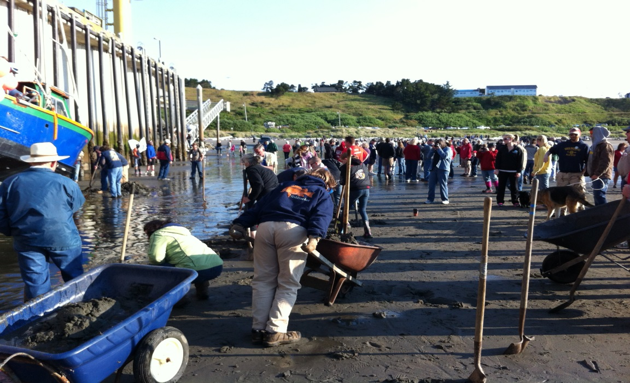
Photo 5 – “Let’s Get Dredged”
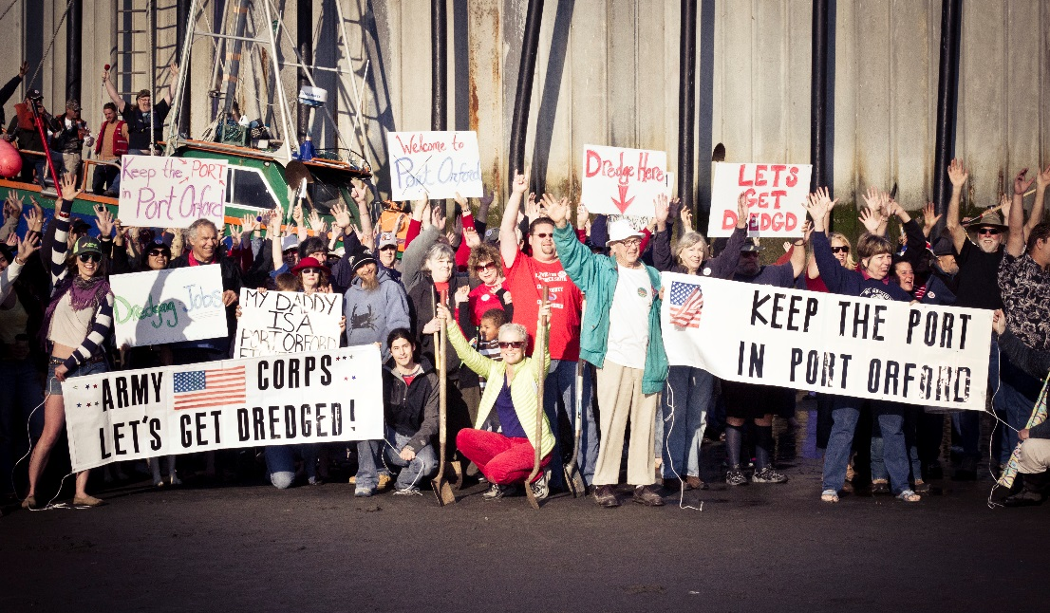
Photo 6 – “Let’s Get Dredged”

Operating Procedures and Governance
Policy decisions at the Port are made by five elected commissioners. The day-to-day operations of the Port and the execution of Port policy are the responsibilities of the Port Manager and staff. The Port Commission and Port staff roles are described below.

Commission
The five-member Port Commission is composed of elected officials who serve staggered 4-year terms as governed by ORS Chapter 777. The Commission meets on the third Tuesday of every month and attends, on average, two board trainings annually. Commissioners and staff attend conferences and events of interest to the Port. For the past four years, Port staff or commissioners have attended the Special Districts Association of Oregon Annual Conference.

Staff
The Port Manager is typically appointed as the Budget Officer and prepares the budget as well as overseeing Port operations and Port staff, including:
An Office Manager, responsible for billing, payroll, banking, word processing, and record keeping.
A Senior Crane Operator, responsible for maintaining the port, daily records and receipts, and the training and scheduling of three crane operators. The current Senior Crane Operator has worked for the Port for 14 years.
- A Hydraulic/Crane Mechanic, who works on an on-call basis to provide routine and emergency crane maintenance. The current Hydraulic/Crane Mechanic has been a Port employee since 2008, but began working with the Port in 2003.
The current Port Manager was hired effective July 1, 2014. He brought with him the experience of a 20 year career with the United States Coast Guard, with extensive experience in vessel operations, safety, and rescue work.

Sites and Facilities
The Port owns several facilities and property on and within the vicinity of the Port’s high dock, including the Port office building, restroom facilities, restaurant building, crane and infrastructure, the cannery, the boneyard and Fishermen’s Memorial area, property along Dock Road and at the intersection of Washington Street and 5th Street (see Photo 7 for an aerial view of Port facilities). Further descriptions and information related to Port-owned property and facilities is included in the technical memorandum that updates the 2008 Capital Facilities Plan and constitutes Appendix C. Through a grant from IFA the Port has contracted with an architectural firm to do a conceptual design of the Cannery building.
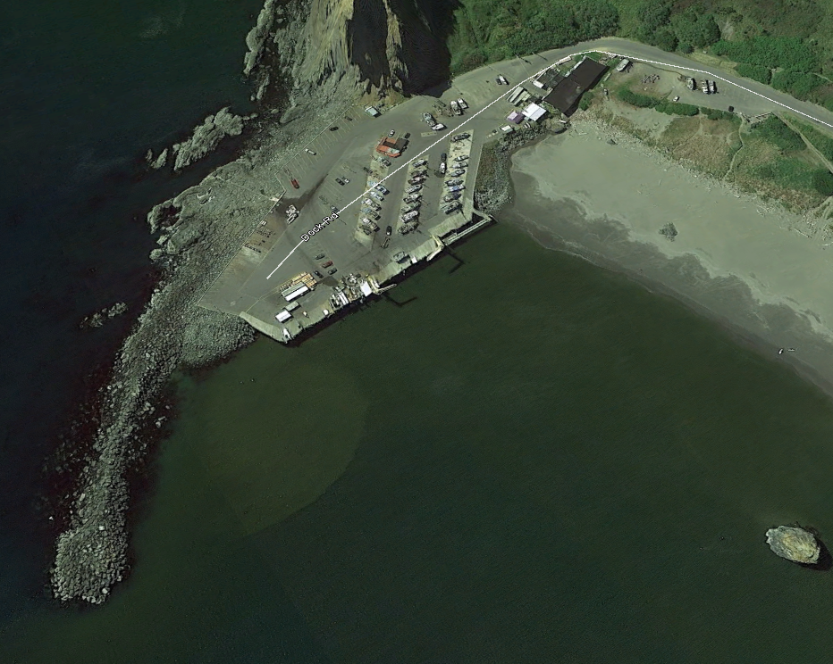
Photo 7 – Port Facilities

Local and Regional Partners
The following section describes the Port’s relationships with local and regional organizations and governments. Maintaining and enhancing these partnerships will enable the Port to leverage efforts to achieve its mission.

Commercial Fishing Industry
The Port and the commercial fishing industry, including fish buyers, are inextricably linked. Since 1965, 95 percent of the Port’s non-tax revenue has come from the commercial fishing industry. The Port has a history of supporting the commercial fishing fleet, even though the price structure has achieved full operational cost recovery it has yet to achieve full capitol replacement cost recovery for dock services. The financial success of the Port is sensitive to state and federal regulation and market fluctuations. The Port has been and should continue to support the fishing industry by
Staying abreast of impending regulation and advocating where appropriate.
Staying in touch with market conditions and responding accordingly.
Seeking ways to diversify the commercial fleet.
- Looking at non-fishing sources of revenue.

City
The Port and the City of Port Orford (City) share the same focus of achieving increased economic development opportunities and they are partners in promoting Port Orford and the culture and heritage of the region. The Port and the City should continue to work together and pursue funding opportunities that will enhance the missions of both organizations.

Port Orford Ocean Resource Team
The Port Orford Ocean Resource Team (POORT), located near Battle Rock, is a Port Orford-based 501(c)(3) non-profit organization. POORT was founded in 2003 to promote the long-term sustainability of ocean resources by “uniting science, education, local expertise and conservation.”1F1F XXXXXXXXXXXXXXXX

Redfish Rocks Community Team
RRCT is a local organization tasked with oversight of the Redfish Rocks Marine Reserve and MPA.

Schools
The 2 CJ School District (school district) and the Port are both committed to providing educational opportunities that prepare today’s students for the challenges of the future. The school district has a successful Information Technology program, but a weak Industrial Arts program within its schools. The Port should work with the school district to support the continued development of these programs, including the pursuit of funding opportunities for equipment and resources related to the Port and vocational education.

Oregon State University
OSU Port Orford Field Station, located at 444 Jackson St. is in close proximity to the Port. The station contains labs, offices, a classroom, and lodging for researchers, including those focusing on research that is of interest to the Port.

Other Organizations
The Port has supported local organizations by allowing them to include announcements in the Port’s monthly billings.
Army Corps of Engineers – for maintenance dredging and whose protocols and help are essential to Port success.
Coast Guard Auxiliary – for providing safety training to Port users.
Coos Curry Electric Co-operative – who have been invaluable with crane maintenance and new underground power and are using the Port’s harsh environment to test new LED lighting.
Fishermen’s Wives – who do the annual Blessing of the Fleet.
National Weather Service – who have had a weather station on the dock since 1924, and alert the Port when potentially damaging weather is approaching.
Port Orford and Sixes Rural Fire Districts.
Port Orford Rotary – of which three commissioners and the Port manager are members.
Southern Oregon Ocean Resource Coalition – a coalition of marine-related interests on the Southern Oregon Coast engaged in proposed uses of Oregon's coastal waterways.
- South Coast Ports Coalition – whose efforts have been instrumental in bringing attention to the ports dredging needs.

Policy context
The Port is committed to furthering all applicable federal, state, and local planning goals. The following section outlines how this Strategic Business Plan meets the intent of key planning goals and policies.

Statewide Planning Goals
Oregon’s land use planning is based on 19 statewide planning goals that apply to state agencies, local governments, and special districts. These goals must be addressed to ensure the Port’s land use and economic development strategies are in compliance with the state’s policies and objectives.
4.1.1 Statewide Planning Goal 9 – Economic Development
To provide adequate opportunities throughout the state for a variety of economic activities vital to
the health, welfare, and prosperity of Oregon’s citizens.
In order to support Goal 9, the Port should continue to pursue diversified revenue streams to facilitate capital projects (see the Financial Plan, Appendix D, for additional details). These capital projects are outlined in section 7.1 of this plan and include dredging, breakwater and crane repair, cannery replacement, expanded commercial & retail space, and potential development of the 5th and Washington site. These projects would generate revenue, create and maintain jobs, and increase the economic viability of the Port. Moreover, these projects are critical to the Port’s primary objective of providing services and support to the commercial fishing industry, which brings in as much as $6.3 million to the Port Orford community annually.2F2F

Statewide Planning Goal 12 – Transportation
To provide and encourage a safe, convenient and economic transportation system.
The state’s Transportation Planning Rule requires that cities, counties, metropolitan planning organizations, and state agencies implement Goal 12 and prepare and adopt transportation system plans. The Port supports local and statewide transportation planning that serves the Port and the community. The Port relies on the surface and water transportation systems to move its products to consumer markets. For this reason, dredging and dock maintenance are as critical as the street and highway system to promoting a “safe, convenient and economic transportation system” that supports the Port and region. There is potential for increased landings, and subsequent revenue enhancement, if the harbor can be restored to its deep water condition, allowing larger vessels to land product there.

Statewide Planning Goal 17 – Coastal Shorelands
To conserve, protect, where appropriate, develop and where appropriate restore the resources and benefits of all coastal shorelands, recognizing their value for protection and maintenance of water quality, fish and wildlife habitat, water-dependent uses, economic resources and recreation and aesthetics. The management of these shoreland areas shall be compatible with the characteristics of the adjacent coastal waters; and
To reduce the hazard to human life and property, and the adverse effects upon water quality and fish and wildlife habitat, resulting from the use and enjoyment of Oregon’s coastal shorelands.
This strategic business plan identifies breakwater modification as a Port priority project (see section 7.1 of this plan). Breakwater modification could eliminate shoaling in the harbor and the need for continued dredging (see Photo 8). This action should also help protect the shoreland and reduce hazards to human life and property.
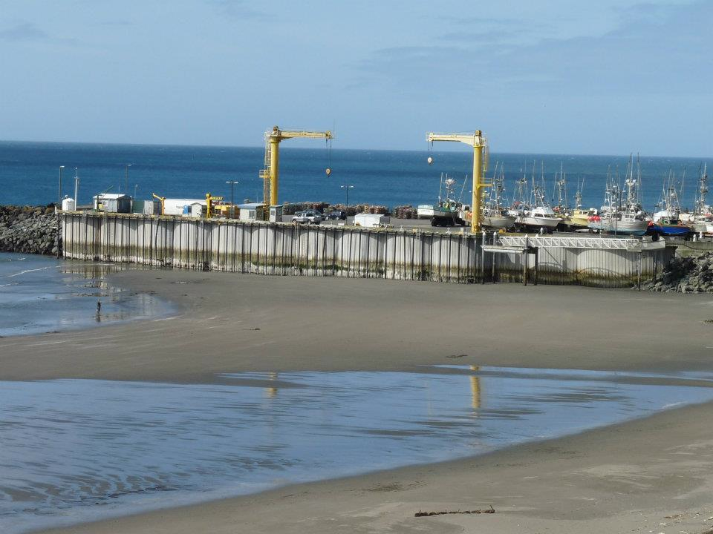
Photo 8 – Shoaling of the harbor as seen at minus tide, June 2012

Statewide Planning Goal 19 – Ocean Resources
To conserve marine resources and ecological functions for the purpose of providing long-term ecological, economic, and social value and benefits to future generations.
This strategic business plan outlines numerous Port actions that support the conservation of marine resources and ecological functions, including:
Coordinating with state and federal research institutions and management agencies to address shared resource issues and encourage diversification of the fishing fleet to include research voyages.
By partnering with local environmental organizations like, X RRCT and POORT.
- Supporting a local commercial fishing fleet that uses environmentally safe and sustainable methods of fishing which support the maintenance of ecosystem structure and biological productivity and diversity.

Local and Regional Plans
In addition to the local and regional plans listed below, this plan is consistent with the Port of Port Orford Strategic Business Plan of 2003 and the Port of Port Orford Facility Master Plan of 2008. This plan and the attached appendices are an update of the 2003 and 2008 plans, reiterating many of the action items that remain incomplete.

City of Port Orford
Comprehensive Plan
In 2012, an ordinance of the Common Council of the City replaced the entire goals and policies section of the Port Orford Comprehensive Plan. The Port supports the goals and policies of the Port Orford Comprehensive Plan through the following actions:
Supporting the recreational needs of the residents of Port Orford and visitors by improving walkways and trails and maintaining access to scenic viewpoints.
Providing ocean access for all levels of users, from beach walkers to ocean kayakers and off-shore recreational fishers.
Working to diversify and improve the economy of Port Orford by replacing deteriorated Port infrastructure, pursuing a solution to harbor shoaling, and encouraging the development of research and tourism facilities.
Supporting an environmentally responsible fishing fleet and promoting fishing as a necessary source of financial security and social welfare in the community.
Supporting the use of renewable energy but not at the expense of high-value fishing.
Supporting the development of aquaculture facilities at the Port.
- Pursuing a partnership with the City for public trail linkages and wayfinding signage that directs visitors to the Port from Battle Rock and other key destinations within Port Orford.

Curry County
The port district encompasses land within Curry County and supports the goals of the Curry County Comprehensive Plan through the following actions:
Pursuing a solution to harbor shoaling that would increase ocean access.
Encouraging increased recreational use and enhanced recreational opportunities on public waters.
Providing key access to vital elements of the county’s economy, including agriculture, commercial fishing, and tourism.
Providing opportunities for the expansion of food production and access to domestic and foreign markets for agricultural products.
- Coordination with other Curry County and southern Oregon ports to achieve a coordinated and local approach to annual dredging needs, including assistance from the state of Oregon.

Defining the CHALLENGE and opportunity
The residents of Port Orford are proud of what sets their small city apart from other coastal communities. Port Orford does not have fast-food restaurants or even a traffic light, but it does have a growing arts community, a hard-working commercial fishing fleet, and access to a wide array of recreational amenities. While the Port faces many challenges as it works toward long-term growth and economic sustainability, the unique attributes of Port Orford create many opportunities for the Port to capitalize on existing economic markets. The following sections describe the demographic and economic profiles of the port district.

District Demographic Profile
In 2015, Curry County’s population was 22,355. Over the 2000 to 2015 timeframe, the average annual population growth rate for the County was well below the statewide average (see Table 1).
Table 1 – Population Trends
 | 2000 Census | 2010 Census | 2014 PSU | Annual Growth Rate
 |  |  |  | 2000-2010 | 2010-2014
Curry County | 21,137 | 22,364 | 22,355 | 0.6% | -0.0%
Port Orford | 1,155 | 1,133 | 1,135 | -0.2% | 0.0%
Brookings | 5,447 | 6,336 | 6,535 | 1.5% | 0.8%
Gold Beach | 1,897 | 2,253 | 2,275 | 1.7% | 0.2%
Oregon | 3,421,399 | 3,831,074 | 3,962,710 | 1.1% | 0.8%
Source: 2000, 2010 U.S. Census; Portland State University (PSU) College of Urban and Public Affairs Annual Population Estimates (data provided by FCS GROUP).

The Oregon Office of Economic Analysis (OEA) expects moderate population growth in Curry County for years to come. As shown in Table 2, Curry County is projected to add 2,119 people between 2015 and 2030. This level of population growth would be expected to support about 815 new dwelling units in Curry County (assumes current Census average of 2.6 persons per household). These housing demand forecasts do not include the additional demand that could be created by seasonal (second home) investments.
Table 2 – Population Trends in Oregon and Curry County
 | 2015 OEA | 2020 OEA | 2025 OEA | 2030 OEA | Annual Growth Rate  2015-2030
Curry County | 22,321 | 23,087 | 23,854 | 24,440 | 0.6%
Oregon | 4,001,600 | 4,252,100 | 4,516,200 | 4,768,000 | 1.2%
Source: Office of Economic Analysis, Department of Administrative Services, state of Oregon Forecasts of Oregon’s County Populations and Components of Change, 2010-2050 (data provided by FCS GROUP).

Community Analysis
Port Orford and Curry County are facing many challenges in light of an aging population and, in Port Orford, a population decline. In 2005, the port district had 3,026 residents; a 0.2 percent decline is assumed for Port Orford as noted in Table 1 above. Despite the overall decline in population, two age groups increased; residents from 50 to 85 (increased by 41 percent), and residents from 20 to 29 (increased by 117 percent). An increase in people nearing or at retirement and young adults may present new opportunities within the retirement industry. The ability to retain young adults in the local area is also a positive sign, but time will tell if new businesses can support these young workers as they advance in their professional careers.
It is estimated that the aggregate income of local residents in Port Orford increased to nearly $30 million in 2013, up from only $19 million in 2000. Over 50 percent of the income into Port Orford is passive or comes from transfer payments like Social Security and retirement benefits, which could contribute to Port Orford’s low percentage of population in the labor force – 44.8 percent for Port Orford compared to 64.1 percent for the state.

District Economic Profile
Port Orford’s existing commercial, retail, and recreation markets include the following.
Commercial fishing: The commercial fishing industry, which includes; fishermen, fish-buyer/tenants and non-tenants, is responsible for 70 percent of the Port’s annual operational revenue.4F4F In addition to the 40 boats that moor on the dock there are an additional 30 commercial boats that trailer in from home on a regular basis or come from out of town for selected fisheries out of Port Orford.
Commercial fish buying and distribution:
- The Port is home to two tenant fish buyers. Hallmark Fisheries has been a tenant at the Port for 40 years, primarily buying crab, salmon, black cod (aka sablefish), tuna, and halibut. The fish is trucked about 50 miles to Charleston, processed, packaged, and delivered worldwide. Norcal Seafoods has been a tenant at the Port for 12 years, buying live crabs and live nearshore rockfish and other groundfish (lingcod, greenling, and Cabezon). The live product is shipped to Norcal’s facility in Oakland, California and distributed throughout California.
- Other non-tenant fish buyers have begun buying live product, at premium rates, off the boats at the Port. This product is sold live in the Portland metropolitan area.
- Port Orford is home to local fish buyer/processor Port Orford Sustainable Seafood (POSS), which sells its products in Port Orford and the surrounding communities, and has developed a Community Supported Fishery (CFA), which distributes shares to members living in the Rogue and Willamette Valleys, such as Ashland and Portland.
- Red sea urchins are purchased by non-tenant buyers, trucked to California, processed, and distributed domestically and internationally.
Recreational boating: The Port draws recreational boaters from Port Orford, the surrounding communities, and the Medford, Roseburg, and Eugene areas. Recreational boating is not as accessible at the Port of Port Orford as at nearby ports because of the lack of a boat ramp, the cost of installing additional lift ropes, and the cost of launching by crane. The addition of a boat ramp or low cost and quick way of launching boats without lift ropes could generate substantial revenue. See pg. 27 (marketing goals)
Two things that must not be lost track of is the Ports designation as a Harbor of Refuge, and the honor of being “The Port Without A Bar.” Because of this and the fact the Port records every launch, how many people aboard, and a description of the vessel it is considered by the Coast Guard as the safest Port in Oregon.
- Scuba diving: The rocky reefs surrounding Port Orford (Orford Reef, and Redfish Rocks), contain some of the best diving in Oregon, perhaps even the West Coast. The presence of an air fill station at the OSU Field Station nearby facilitates diving in the area, and the Port should market to the scuba community with the Redfish Rocks Marine Reserve and nearby Orford Reef as draws.

Economic Strengths and Weaknesses
The economic strengths and weaknesses of the port district are influenced by the broader regional and state economies. Analyzing the Port’s economic profile within this context can provide valuable insight and lead to policies that target appropriate industry sectors.5F5F

Employment and Jobs
According to the Oregon Employment Department (OED), in 2014, Curry County had 6,060 jobs covered by unemployment insurance. The current level of employment is down from the recent peak of 7,110 jobs in 2005. The employment sectors in Curry County that grew the fastest between 2010 and 2013 were mining and logging, education and health services, and manufacturing (see Table 3 and Table 4).
Table 3 –Non-Farm Employment Trends by Sector in Curry County
 | 2001 | 2006 | 2010 | 2015 | Annual Growth Rate 2010-2015
 |  |  |  |  | Change | Percentage
Industrial Trades* | 1,420 | 1,660 | 1,240 | 1,150 | (90) | -1.50
Retail Trade | 1,080 | 1,070 | 970 | 910 | (60) | -1.27
Services | 2,520 | 2,940 | 2,630 | 2,690 | 60 | 0.45
Government | 1,430 | 1,400 | 1,350 | 1,290 | (60) | -0.91
Total | 6,450 | 7,070 | 6,190 | 6,040 | (150) | -0.49
*Includes construction, manufacturing, wholesale trade, transportation, utilities and mining/logging businesses.
Note: Employment includes workers “covered” by unemployment insurance.
Source: OED; compiled by FCS GROUP.
Table 4 –Curry County Employment Trends by Sector
Sector | 2001 | 2006 | 2010 | 2015 | Annual Growth Rate 2010-2015
 |  |  |  |  | Change | Percentage
Total Nonfarm Employment | 6,450 | 7,070 | 6,190 | 6,040 | (400) | -1.33
Total Private | 5,020 | 5,670 | 4,840 | 4,500 | (340) | -1.45
Mining and Logging | 170 | 150 | 100 | 120 | 20 | 3.71
Construction | 390 | 660 | 390 | 270 | (120) | -7.09
Manufacturing | 660 | 640 | 540 | 580 | 40 | 1.44
Wood product manufacturing | 480 | 480 | 380 | 410 | 30 | 1.53
Trade, Transportation, & Utilities | 1,280 | 1,280 | 1,180 | 1,090 | (90) | -1.57
Retail trade | 1,080 | 1,070 | 970 | 910 | (60) | -1.27
Information | 140 | 100 | 80 | 60 | (20) | -5.59
Financial Activities | 300 | 490 | 410 | 330 | (80) | -4.25
Professional & Business Services | 320 | 400 | 430 | 320 | (110)- | -5.74
Educational & Health Services | 540 | 630 | 570 | 680 | 110 | 3.59
Healthcare | 430 | 510 | 480 | 560 | 80 | 3.13
Leisure & Hospitality | 1,030 | 1,130 | 990 | 900 | (90) | -1.89
Arts, entertainment, and recreation | 80 | 60 | 50 | 40 | (10) | -4.36
Accommodation & food services | 960 | 1,070 | 940 | 860 | (80) | -1.76
Other Services | 190 | 190 | 170 | 150 | (20) | -2.47
Government | 1,430 | 1,400 | 1,350 | 1,290 | (60) | -0.91
Federal Government | 130 | 100 | 110 | 70 | (40) | -8.64
State Government | 270 | 250 | 220 | 180 | (40) | -3.93
Local Government | 1,030 | 1,060 | 1,030 | 1,040 | 10 | 0.19
Local education | - | 440 | 400 | 370 | (30) | -1.55
Local gov. excluding educational service | - | 610 | 630 | 670 | 40 | 1.24
Source: OED; compiled by FCS GROUP.
The OED forecasts an 11 percent increase in employment in the South Coast region (Coos and Curry counties) over the 2010 to 2020 period. A net increase of 2,980 jobs is forecast over the next 10 years. The largest increases in job growth are expected in education and health services and professional and business services. Sectors gaining jobs also include leisure and hospitality (hotels, motels and restaurants), retail trade, natural resources (farming, fishing, aquaculture, and mining), and manufacturing (see Figure 1).
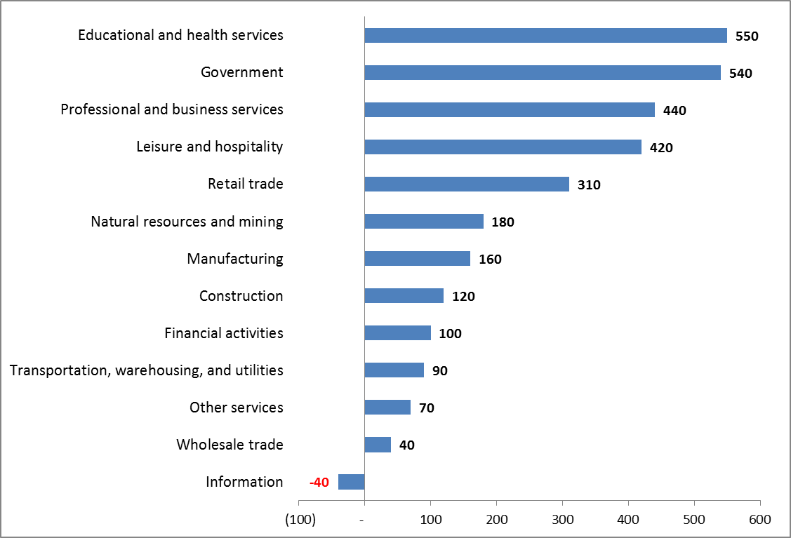
Note: Fisheries are included in natural resource and mining category; seafood processing is included in manufacturing, wholesale trade, and/or warehousing.
Source: OED, region includes coos and Curry counties (data provided by FCS GROUP.

Figure 1 –Employment Forecast for South Coast Region, 2010–2020

Future job growth in the South Coast Region (Coos and Curry counties) will be impacted by tourism trends as well as changes in federal and state regulations that affect the fishing and timber industries. Expanding global and domestic demand for seafood, wood products, and natural resources could bode well for the South Coast economy.
Based on Oregon Employment Department job growth forecasts for the South Coast Region, we would expect there to be positive demand for a variety of industrial and non-industrial development over the next 20 years. While the timing for future investment must account for risk levels carefully, it is evident that several private and non-profit businesses operating locally have the potential to expand operations over time. The Port will need to evaluate its role carefully in participating directly in new industrial development, and the ways it may leverage desired private investment using its limited financial and land resources. Possible market-supportable developments over the next 20 years are identified in Table 5.
Table 5 –Projected Non-Farm Employment Land Need - 20 year Forecast
Lower-Growth Forecast
Job/Use Type | 20-Year Forecast Job Growth¹ | Jobs/Acre³ | Building Floor Area/Job³ | 20-Year Land Need (net acres)⁴ | Building Floor Area Need | Port Orford Potential
Industrial²
Manufacturing | 6 | 12 | Varies | 0.6 | 5,000 | Seafood Processing
Warehousing | 9 | 8 | Varies | 1.3 | 11,000 | Climate Controlled
General industrial/flex | 40 | 14 | Varies | 3.2 | Varies | Showroom, Artisan
Energy/ Utilities | 5 | 4 | Varies | 1.4 | Varies | R&D
Other | 1 | 6 | Varies | 0.2 | 2,000 | NGO
Industrial Subtotal | 62 |  |  | 6.5
Retail trade | 38 | 18 | 500 | 1.2 | 19,000 | Moderate
Services | 200 | 38 | 350 | 4.6 | 70,000 | Good
Retail/Services Subtotal | 238 |  |  | 5.8 | 89,000
Notes:
¹ Derived from lower-growth forecast for private “covered” employment in south coast region (includes Coos and Curry Counties). Assumes 10-percent work at home adjustment for service jobs.
² Assumes Port Orford captures 5 percent of Curry and Coos County job growth.
³ Assumptions for job densities reflect “covered jobs” and are generally consistent with Oregon Department of Land Conservation and Development, Industrial and Other Employment Land Analysis Handbook, 2001.
⁴ Assumes net land area is adjusted upwards by 12 percent for public road circulation, easements and utilities.
Source: FCS GROUP based on assumptions provided above and Oregon Employment Department job growth forecasts.

Commercial Fishing Fleet Analysis
As noted in the Financial Plan (Appendix D), the economic success of the Port is currently tied to the commercial fishing industry. In 2010, 11.4 percent of the population of Port Orford was working in the commercial fishing industry and 29.7 percent of the total labor force in Port Orford was directly involved in commercial fishing. Each boat docked at the Port represents two to three full-time employees (FTEs) and the Port supports 130 direct jobs in the fishing industry.
Table 6 below shows historical seafood values in Port Orford.
Table 6 – Historical Seafood Values in Port Orford
Year | Crab | Salmon | Black Cod | Urchin | Rock Cod | Total Landings
1979 | $877,933 | $658,208 | $692,131 | N/A | $56,839 | $2,285,111
1980 | $1,045,493 | $746,751 | $4,776 | N/A | $34,837 | $1,831,857
1981 | $637,671 | $529,485 | $610 | N/A | $24,520 | $1,192,286
1982 | $593,149 | $743,437 | $115,881 | N/A | $44,869 | $1,497,336
1983 | $578,417 | $121,339 | $339,931 | N/A | $243,468 | $1,282,155
1984 | $664,482 | $248,118 | $179,187 | N/A | $57,271 | $1,149,058
1985 | $685,975 | $158,272 | $385,372 | N/A | $66,193 | $1,295,812
1986 | $202,771 | $261,623 | $353,582 | $14,708 | $204,353 | $1,037,037
1987 | $362,675 | $935,691 | $201,919 | $41,417 | $203,824 | $1,745,526
1988 | $188,382 | $1,183,406 | $49,425 | $441,272 | $158,743 | $2,021,228
1989 | $489,695 | $705,210 | $25,062 | $2,109,250 | $263,071 | $3,592,288
1990 | $775,882 | $345,825 | $77,930 | $2,648,520 | $295,169 | $4,143,326
1991 | $204,184 | $32,354 | $312,058 | $2,107,541 | $422,822 | $3,078,959
1992 | $621,776 | $14,685 | $255,376 | $1,649,134 | $339,738 | $2,880,709
1993 | $348,401 | $57,455 | $256,718 | $1,246,398 | $368,708 | $2,277,680
1994 | $606,224 | $70,368 | $432,869 | $962,538 | $394,317 | $2,466,316
1995 | $1,025,461 | $37,373 | $654,321 | $611,521 | $248,355 | $2,577,031
1996 | $1,678,857 | $68,498 | $824,378 | $237,355 | $319,309 | $3,128,397
1997 | $588,757 | $48,281 | $1,241,097 | $178,280 | $619,870 | $2,676,285
1998 | $780,111 | $82,408 | $262,756 | $49,665 | $624,167 | $1,799,107
1999 | $1,347,410 | $159,826 | $473,504 | $67,763 | $673,793 | $2,722,296
2000 | $945,550 | $141,953 | $488,868 | $292,444 | $470,016 | $2,338,831
2001 | $699,857 | $170,565 | $382,466 | $244,812 | $789,011 | $2,286,711
2002 | $475,681 | $196,180 | $103,726 | $103,726 | $766,079 | $1,738,524
2003 | $807,448 | $242,760 | $495,154 | $25,790 | $424,419 | $1,995,571
2004 | $3,319,512 | $480,970 | $438,930 | $47,683 | $491,324 | $4,778,419
2005 | $971,363 | $502,930 | $912,491 | $84,840 | $456,844 | $2,928,468
2006 | $1,718,371 | $169,531 | $778,612 | $64,952 | $442,897 | $3,174,363
2007 | $1,764,643 | $215,699 | $705,146 | $81,533 | $581,434 | $3,348,455
2008 | $876,673 | $20,344 | $1,030,577 | $138,689 | $678,401 | $2,744,684
2009 | $2,014,442 | $29,714 | $1,662,752 | $194,721 | $785,494 | $4,687,123
2010 | $783,922 | $154,780 | $1,696,255 | $107,150 | $643,652 | $3,385,759
2011 | $3,119,647 | $263,832 | $1,894,985 | $163,625 | $891,586 | $6,333,675
2012 | $1,439,476 | $198,402 | $634,648 | $153,052 | $829,692 | $3,255,270
2013 | $3,286,982 | $474,516 | $430,028 | $271,496 | $770,975 | $5,233,997
2014 | $1,460,223 | $517,049 | $502,212 | $255,373 | $645,127 | $3,379,984
2015 | $1,103,107 | $466,790 | $596,083 | $217,671 | $778,693 | $3,162,344
Totals | $39,090,603 | $11,455,306 | $19,984,270 | $14,812,919 | $16,109,880 | $101,452,978
Source: Port of Port Orford

See the Financial Plan (Appendix D) for additional details related to Port revenue generated from the commercial fishing industry.

Situational Analysis
The following section identifies the Port’s strengths, weaknesses, opportunities and threats (SWOT) based on public outreach and Port Commission and staff input. The public outreach included an August 8, 2013 public meeting followed by a Port Commission workshop. The full meeting summary is included within Appendix B.
Table 7 reflects the results of the SWOT analysis completed during the Port Commission workshop.
Table 7 – SWOT Analysis
Strengths | Weaknesses
- Diversity of fisheries  - Hook and line fishing (live catch and sustainable)  - Engaged in policy development (South Coast ports dredging effort)  - Assets – land and facilities  - Isolated Port operations that reduce conflicts with neighboring property  - Sea water/energy research and development  - Jetty – quality rock source nearby for rehabilitation  - Visual and scenic resources  - Innovative ideas and people  - Youth facilities (skate park, baseball fields, horse arena)  - Open ocean access  - National fish sales/tenants  - Regional partnerships  - Housing availability  - Fisheries research to support the cannery  - Record of safety | - Reliance on one industry  - Transportation (isolated from I-5)  - Lack of dredging  - Lack of industrial diversification  - City water used for industry (expensive)  - Deferred maintenance
Opportunities | Threats
- Small cruise ship access  - Short shipping  - Growth in specialty fisheries  - Branding and marketing  - Financial (marine research)  - Capture tourism (gateway on Hwy 101, pedestrian improvements at the high dock)  - Cannery reconstruction (local fish production)  - Internship opportunities for university students  - Port repair shop  - Biomass production (pellets)  - Eco-tourism  - Spring water development | - Fisheries regulations  - No long-term dredging solution  - Reliance on crane/boat lift  - Shoaling  - Aging fleet and increased start-up cost to enter fishing industry.

Strategic business plan
The following section captures the Port’s priority projects, including high dock improvements, cannery replacement, expanded retail space, the 5th and Washington opportunity site, and Port Gateway projects. These projects are followed by supportive goals and strategies to help achieve the Port’s mission of job creation and long-term economic viability.

Port of Port Orford Priority Projects
The following section outlines the Port’s priority projects for the next 20 years.

Shoaling/Dredging
Prior to the construction of the breakwater, the Port was a deep-water port accommodating up to 400-foot lumber carriers. One year after the breakwater was built, the harbor became shoaled, necessitating emergency congressional authorization for the first dredging of the harbor. Since that time shoaling has been the major issue for the Port, due to the unique nature of the crane operated boat launch, and vulnerability to shoaling at this critical dockside location in the harbor.
To address and help alleviate this problem, recent actions taken by the Port include attainment of removal – fill permits for two disposal sites
The Breakwater Disposal site (7,000 cubic yards)
The Nearshore Disposal site (30,000 cubic yards)
Through a $150,000 appropriation by the Oregon Legislature the port has purchased dredge equipment, including
- 1,600 feet HDPE 8-inch pipe
- 150 kW Tier 1 diesel generator.
- 75 hp Toyo dredge pump, and related equipment
Since January 3, 2015, dredged 332 man hours.
Dredged approximately 5,879 cubic yards of sand at a cost of $2.20/cy
- XXXXXXXXXX
In recognition of the severity of the problem, the Oregon State legislature, led by the Coastal Caucus, has appropriated up to $5,000,000 to the U.S. Army Corps of Engineers (USACE) for port dredging. Port Orford received $336,000 for a contractor to dredge 7,000 cubic yards of material and teach Port personnel how to operate the suction dredge equipment.
In the spring of 2014, the Oregon Congressional Delegation announced all the coastal ports received operations and maintenance dredge funding for FY 2014. Port Orford received $1.2M, its largest appropriation ever.
Additionally, Oregon and the Coastal Caucus have been working together to find a solution to dredging at seven ports on the southern Oregon coast. In 2014, Coast & Harbor Engineering (CHE), in association with BergerABAM, was hired by the Oregon Infrastructure Finance Authority to evaluate the feasibility of an Oregon State-funded purchase of dredging equipment to serve these seven ports along the Oregon coast (Port of Siuslaw, Port of Umpqua [Salmon Harbor Marina], Oregon International Port of Coos Bay [Charleston Marina Complex and Boatyard], Port of Bandon, Port of Port Orford, Port of Gold Beach, and Port of Brookings Harbor). A summary of CHE’s analysis, Dredge Equipment Operational Analysis and Business Plan Technical Report, is included in Appendix E. Details related to the Port of Port Orford’s dredge requirements are summarized in Table 8.
Table 8 – Port of Port Orford Dredging Requirements
Dredge Location | Annual Maintenance Dredging Volume (cubic yards) | Sediment Type | In-Water Work Windows | Permit Summary
Port of Port Orford | 10,000 | Poorly graded sand with shell hash (coarse sand) | - May 1 to April 15 | - USACE permit expires January 2018  - DSL permit expires October 31, 2018

In order to serve the dredging requirements of each of the seven study ports, CHE evaluated three dredge equipment alternatives. Based on the technical requirements, as well as operational costs, dredge equipment purchase cost, and production rates, a 12-inch hydraulic cutterhead dredge 370 HP with a discharge pipeline of 12 inches and an 8-inch Toyo pump dredge were selected as the preferred alternative to meet the needs of each of the study ports. Considering the operational costs and ownership cost of the preferred dredge equipment alternative, the report concluded that the cost per cubic yard of dredged material for an annual maintenance dredging volume of 63,000 cubic yards would be approximately $7.20 per cubic yard. The study did not take into account mitigation costs that might be associated with securing dredging permits or costs associated with securing or retaining upland disposal sites.
Given the Port of Port Orford’s unique location, the preferred dredging equipment alternative will not meet the dredging needs of the Port. However, Port Orford was granted $150,000 to purchase a submersible pump and related equipment to dredge along the dock in Port Orford, to enable essential operations. The Port of Port Orford and the Port of Brookings Harbor have established an intergovernmental agreement to share dredge equipment in order to perform dredging at Port Orford and in the Brookings Harbor.
As a follow up to CHE’s report, FCS GROUP completed a financial analysis to evaluate the ability of individual ports to contribute to the cost of annual maintenance dredging (Appendix F). Although the Port’s dredging needs are different from the other south coast ports, it is still recommended that the Port of Port Orford contribute 20 percent of General Fund ending fund balances to a Dredging Maintenance Reserve Fund to support its dredging activities. This recommendation is included in the Port’s Goals and Strategies (see section 7.2). In addition, the Port completed a dredging cost estimate for a submersible pump, included as Appendix G. The Port also has one-year of dredging experience with a submersible pump and new preliminary cost estimates.

Breakwater
Because of the cost of dredging, boat damage, and limited launching caused by shoaling, there is interest in modifying the breakwater to alleviate the shoaling problem. The USACE stated in its July, 2014 breakwater inspection report that the role that the breakwater plays in encouraging sediment deposition should be evaluated prior to designing a repair of the structure. In the summer of 2014, clam shell dredging, at a cost of $1.2 million, provided some time to analyze the efficacy and cost of the submersible pump in preserving the channel

Southwest Corner of Dock
Since the High Dock was completed in 2001 there have been three major storms that have caused major damage on the dock and flooding of the Port office. This is due to wave over-topping at the SW corner of the dock where the breakwater is narrow allowing waves to break the full width of the high dock. Repair of, or modification to the breakwater should include design elements that will address this vulnerability and mitigate damage to the dock as shown in Photo 9.
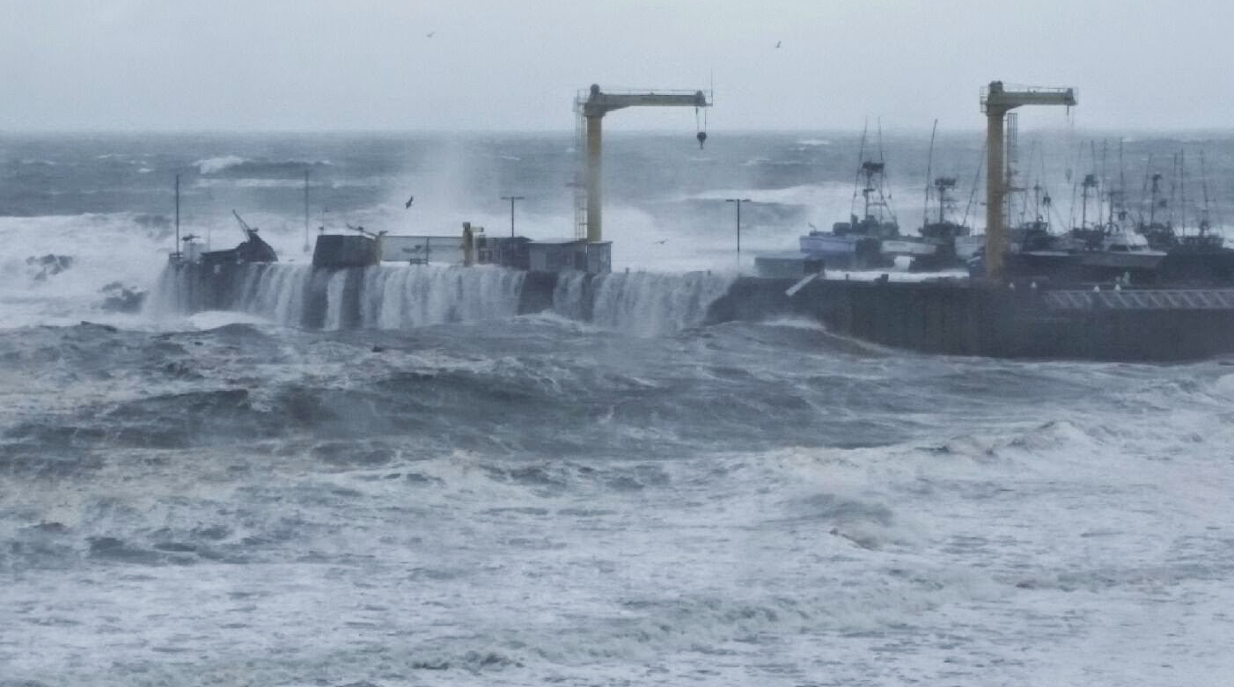
Photo 9 – Flooding and damage caused by +30-foot waves, October, 2014

Cannery Replacement
In order for the Port to retain existing and potential new tenants, it must replace the cannery building, which is in disrepair and uninsurable. At its peak, the cannery provided up to 75 jobs processing crab, shrimp, salmon, and rockfish (see Photo 10) and, in the 1990s, red sea urchins destined for Japan.7F7F Originally built in the early twentieth century, the cannery is currently occupied by Norcal Seafoods. The redevelopment project would demolish the existing cannery and construct a new building from 10,000 to 20,000 square feet, which would allow the consolidation of several existing smaller outbuildings into one main structure (see Cannery Pro Forma Memorandum, Appendix H). The redevelopment of the cannery and associated improvements would create jobs, economic development opportunities, improve tenant operating efficiencies, and provide space for additional tenants as well as new Port office space (see Figure 1).
The Port has obtained a Planning and Marketing grant from the Oregon Infrastructure Finance Authority, and is now in the process of contracting for engineering and architectural services to develop a Cannery Development Plan.
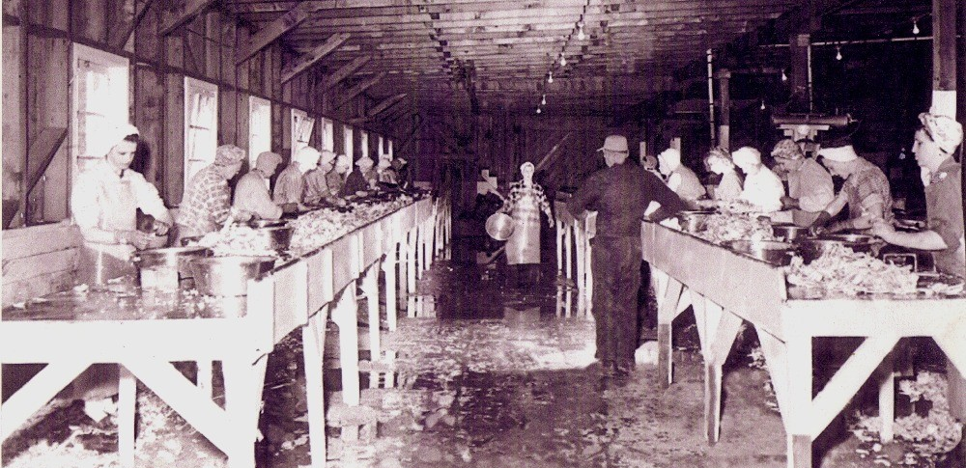
- In addition, the Port has received an appropriation from the Oregon State legislature in the amount of $400,000 toward the Cannery Redevelopment Project.
Photo 10 – The Cannery, 1960s
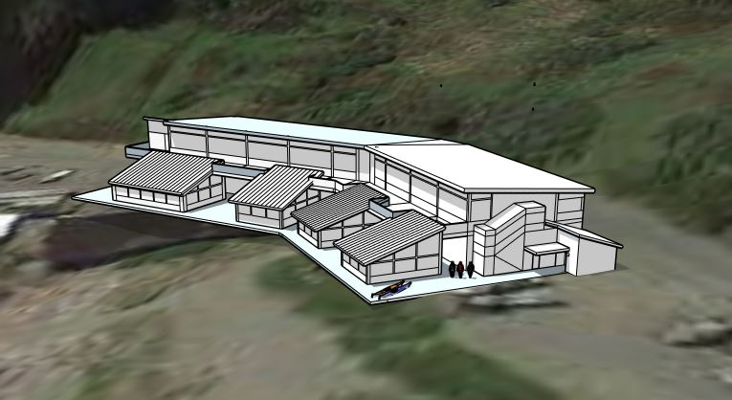
Figure 2
Figure 2 – Rendering by Crow/Clay showing redeveloped cannery and commercial/ retail flex space conceptual design
Commercial/Retail and Flex Space
The focus of this development is the creation of a public attraction, a commercial-retail facility that will draw more visitors to the City and the Port. To be located next to the new cannery building in what is now called the boneyard, near the Fishermen’s Memorial. The 2008 Facility Master Plan broke down these two projects into two separate projects occurring several years apart from each other. However combining these two separate projects would have a huge cost saving in the long run, and produce substantial additional revenue at completion.
5th and Washington Opportunity Site
This Port-owned property, located on the southeast corner of 5th and Washington streets, is a prime location for commercial development. The vacant 5th and Washington development site is approximately 30,000 square feet in area and could provide an opportunity for a public-private partnership. Development ideas for the property range from a commercial/retail facility to a marine research and interpretive center.
All previous board policies and business plans have been resolute to not sell this property.

Gateway/Pedestrian Access and Amenities
In order to provide greater pedestrian access and capture tourism-generated revenue, the Port should partner with the City to develop a plan for a gateway feature/entry, public trail linkages and wayfinding signage from Highway 101 and Battle Rock and other recreation sites throughout the City. In addition to wayfinding signage, the Port should work with the Cape Blanco Heritage Society to develop interpretive signage that reflects the rich history of the Port and surrounding area. The Port has a unique opportunity to create a gateway to the Pacific Ocean and develop greater pedestrian and recreational amenities. These amenities must be planned and developed to ensure pedestrian safety in the context of commercial Port operations.
Table 9 outlines Port of Port Orford priority projects, planning-level cost estimates, timelines, and possible funding sources.
Table 9 – Priority Projects
Priority Project | Timeframe* | Estimated Cost | Potential  Funding Sources
High Dock Repair and Maintenance | Short-term/ ongoing | Initial dredging $300,000 to $850,000;  Permits: $4,000 to $5,000 every 5-years; Crane bearing repair $250,000 to $350,000; /Breakwater modification $300,000 to $600,000; Full Breakwater repair $3 M; Feasibility study $15,000 to $20,000; Major maintenance items (Asphalt parking lot sealant $20,000; bluff stabilization $TBD; paint cranes $TBD) | Port reserve fund; state funding and federal grants, US Army Corps of Engineers
Cannery Replacement | Short-term | $640,000 to $3.2 M | Economic Development Administration (EDA) grant or loan; state and other grants.
5th and Washington Development | Mid-term | $2.0 M to $3.5 M | Private investment; public/private partnership
Commercial/Retail Flex Space | Mid-term | $500,000 to $3 M | Private investment; public/private partnership
Gateway/Pedestrian Access and Amenities | Short to long-term | $835,000 to $3,485,000 | State grants; Port and City staff time
*Anticipated timeframe of project completion (short-term: 1 to 5 years; mid-term: 6 to 10 years; long-term 11 to 20 years).
Note: Dredging maintenance is anticipated at $300,000 annually; other ongoing maintenance costs have not been assessed. Values represent 2013 dollars.

Other Major Maintenance Items
Seal Parking Lot
Stabilize Bluff
- Paint Cranes (completed in 2015)

Goals and Strategies
The following section outlines the Port’s management, financial, environmental, and marketing goals and strategies that have been developed to support priority projects and further the Port’s mission statement.
Management Goal: To increase the efficiency and effectiveness of Port activities and manage the long-term economic growth of the Port.

Strategies
Provide staff and Commission members with ample training in the management skills needed for all operations and to lead the Port’s future capital improvements.
- In order to maintain Port operations, pursue partnerships with local universities and trade schools, providing on-the-job training to students while gaining economical technical support for Port management.
Financial Goal: To ensure the future success of the Port through diversified revenue streams and maintaining the financial feasibility of completion of the Port’s priority projects.

Strategies
Maintain a general fund operating reserve equal to at least 90 days of expenditures.
Charge rates and fees that recover 100 percent of the full cost of Port services.
Consider the economic benefits and/or liabilities of Port policies and investment opportunities.
- Where appropriate, pursue federal and state funding for priority projects.
- Transfer 20 percent of General Fund ending balances to a Dredging Maintenance Reserve Fund.
Capital Facilities Plan Goal: Pursue funding to implement a 5-year capital improvement plan and longer-term projects that promote the Port’s mission.

Strategies
Maintain a 5-year capital improvement plan that addresses the Port’s priority projects, as shown in Table 10. (Table 10 also lists mid- and long-term projects.)
Monitor grant opportunities and market conditions to address mid- to long-term capital project needs.
Amend priorities within the capital improvement plan through annual updates based on market conditions, reserve funding, and grant opportunities.
Maintain reserves, seek new revenues, and seek local, state, and federal grants to develop capital improvement plan projects.
Conduct a non-potable water feasibility study to reduce the use of potable water in fishery operations, reduce costs and further implement capital improvement plan projects.

Table 10 – Capital Improvement Plan
 |  |  | Capital Improvements |  |  |  |  |  | 2015 Cost Est. |  |  |  |  | Timeline |  | Priority | Potential Funding Sources | Priority Project Category
 |  |  |  |  |  |  |  |  | Low |  |  |  | High
1 | Annual Maintenance Dredging – with submersible pump |  | Coordinate with USACE, the State, and Coastal Caucus to meet annual maintenance dredging needs. |  |  |  |  |  | Approximately $20,500 for 7,000 cubic yards |  |  |  |  | yrs 1-5 |  | High | USACE; Oregon State Infrastructure Finance Authority; other grants. | High Dock Repair and Maintenance
2 | Full Breakwater Study and Repair |  | Breakwater alternatives study and repair/replacement. |  |  |  |  |  | $3,000,000 |  |  |  | $3,000,000 | yrs 6-20 |  | High | USACE; state and federal grants. | High Dock Repair and Maintenance
3 | Breakwater Widening |  | Widen breakwater to protect high dock from flooding. |  |  |  |  |  | $300,000 |  |  |  | $600,000 | yrs 1-5 |  | High | Port reserve fund; state and federal grant funding. | High Dock Repair and Maintenance
4 | Cannery Replacement |  | Demolition of existing cannery and new construction. |  |  |  |  |  | $640,000 |  |  |  | $3,200,000 | yrs 1-5 |  | High | EDA grant or loan; state and other grants. | Cannery Replacement
5 | Crane Repair |  | Crane repair/replacement (slew bearing replacement). |  |  |  |  |  | $250,000 |  |  |  | $350,000 | yrs 1-5 |  | High | Port reserve fund; state and federal grant funding. | High Dock Repair and Maintenance
6 | 5th and Washington Development |  | Development at the 30,000-square-foot unimproved site, including utilities, parking, and access associated with new commercial/retail development. |  |  |  |  |  | $2,000,000 |  |  |  | $3,500,000 | yrs 6-10 |  | Medium | Private investment; public/private partnership. | 5th and Washington Development
7 | Non-potable Water Feasibility Study |  | Conduct a non-potable water feasibility study to reduce the use of potable water in fishery operations. |  |  |  |  |  | $15,000 |  |  |  | $20,000 | yrs 1-5 |  | Medium | Port reserve fund; state and federal grant funding. | High Dock Repair and Maintenance
8 | Commercial/ Retail and Flex Space |  | Development of Boneyard area to include flexible commercial/retail space to promote tourism. Further details in 2008 Facilities Master Plan. |  |  |  |  |  | $500,000 |  |  |  | $3,000,000 | yrs 1-5 |  | Medium | Private investment; public/private partnership. | Commercial/ Retail and Flex Space
9 | Gateway/ Pedestrian Access and Amenities |  | Entry gateway, trails, benches, wayfinding and interpretive signage; safety measures to separate pedestrians from Port operations. |  |  |  |  |  | $335,000 |  |  |  | $485,000 | yrs 6-20 |  | Medium | State grants; Port and City staff time. Partnership with Cape Blanco Heritage Society. | Gateway/ Pedestrian Access and Amenities
 | Total |  |  |  |  |  |  |  |  | $7,060,500 |  |  | $14,175,500
Note: Annual maintenance dredging cost is based on an analysis conducted by the Port (see Appendix G). Major maintenance items listed within the High Dock Repair and Maintenance category include asphalt pavement sealant anticipated at $20,000, bank stabilization, crane painting and other ongoing maintenance costs that have not been assessed. Dredging permit costs are anticipated at $4,000 to $5,000 every 5-years. Values represent 2015 dollars.

Environmental Goal: To ensure sustainable growth of Port operations and encourage and promote environmental stewardship among Port tenants.
Strategies
Avoid the need for long-term mechanical dredging by pursuing breakwater modification that promotes natural ocean action to flush the harbor.
Review Port environmental policies and procedures.
Maintain the Port’s high fueling standards.
Continue annual underground storage tank inspections.
- Pursue partnerships that promote green jobs.8F8F
Marketing Goal: To promote Port Orford as a destination for commerce and recreation.
Strategies
By using the new dredge equipment keep the recreational crane and floating dock for its intended use.
- Safely lifting any recreational boat that is not equipped with lift ropes
- Allowing recreational and charter customers to safely walk down the ramp to board rather than the using the ladder or riding the boat up and down.
- The potential market is any boat with a trailer traveling Highway 101.
Apply for marketing grants through the Oregon Tourism Commission to promote tourism, recreational boating and scuba diving.
Support the commercial fishing industry and efforts to increase the market value of seafood products.
Redesign the Port website to increase electronic access to Port amenities and reach a greater audience.
- Coordinate with neighboring ports, economic development agencies, and the state to promote Port Orford as a unique destination and place to do business.

Implementation plan
The following section outlines the actions and updates necessary for successful implementation of this strategic business plan.

Action Plan
The Port will review and adopt its strategic business plan, seek acknowledgement from Business Oregon, and immediately begin implementation. The Port’s priority projects and specific goals and strategies that lead to their successful implementation are outlined above in section 7.0. After acknowledgement from Business Oregon, projects within the Port’s approved plan will be eligible for state funding.

Plan Adoption and Update
The Port of Port Orford strategic business plan is presented for review and adoption by the Port Commission and acceptance by Business Oregon. The plan should be updated as necessary to address new opportunities and accommodate changing conditions. An annual review of the Port’s priority projects should be conducted to gauge success factors and financial viability. The state requires a complete plan update every 10 years with major elements updated every 5 years.

Port of Port Orford
Strategic Business Plan
Port Orford, Oregon

Appendix A
Meeting Summaries

Not included--See Office copy

Port of Port Orford

Strategic Business Plan
Port Orford, Oregon

Appendix B
Mission Statement Definitions

Port of Port Orford
Strategic Business Plan
Port Orford, Oregon

Appendix C
Port Facilities Technical Memorandum

MEMORANDUM
Date: 14 October 2013
Subject: Port of Port Orford Facility Condition Assessment
From: Scott McMahon, PE
To: Scott Keillor, AICP

OVERVIEW The Port of Port Orford (Port) owns two properties in Port Orford, Oregon (see Table 1). BergerABAM performed a facilities condition assessment of all Port properties, including the Port and the 5th and Washington opportunity site. The marina includes the Port’s administrative offices, cannery building, and the high dock.

The assessment included a visual reconnaissance and review of available technical reports and drawings provided by the Port (see attached Reference). BergerABAM did not perform any calculations or testing. Scott McMahon and Scott Keillor visited the sites on 24 October 2012 with Port staff.

Table 1. Port Properties

Tax Lot Number Description of Property
33S15W05-200 Port Site
33S15W05DA-8700 5th & Washington Site

PORT SITE

Overview
The Port is located on the Pacific Ocean in Port Orford on an approximate 14‐acre site (see Figure 1).

The Port features an openwater sheet pile dock (high dock) (see Figure 2). The current sheet piledock was built in 2002, replacing a timber dock and boat ramp. Upland of the face of dock, the
parking and storage area is asphalt with isolated reinforced concrete parking pads for boat
storage. The dock is the only dolly dock on the West Coast where boats are lifted to and from
the water with cranes (see Figure 3). The boats are stored on custom made trailers (dollies) that can be transported around the dock. The high dock provides approximately 40 dry storage slipsand can accommodate vessels up to 42 feet in length. All of the boat storage slips have tie downs to prevent movement during storms. Storms can create waves that overtop the railings of the Port and cause flooding and property damage. Overall, the dock appears to be in good
condition.

There is a perimeter rock breakwater that protects the high dock to the south (see Figure 4). The U.S. Army Corps of Engineers (USACE) owns the rock breakwater that was originally
constructed in 1935 by local parties and then extended 550 feet by the USACE in 1968.
Significant shoaling has occurred at the Port since the breakwater was installed. The shoaling
restricts crane activity to high tide conditions. The sand accumulates at the northern end of the harbor, greatly reducing the depth of water. The Port has not been dredged since 2010;
however, USACE has committed to dredging this year and is anticipating a contract award in
December 2013. In 2011, USACE provided a Major Maintenance Report of 6 alternatives to
remedy the shoaling issue caused by the breakwater while still maintaining the wave protectivefunction. These alternatives ranged from removal to repairs of the breakwater. The most
costeffective alternative would be to create a midsection notch in the breakwater that would
also generate the greatest transport of sediment away from the dock face. We understand
additional studies will be undertaken to evaluate alternatives.

There are two Aurora cranes available at the Port to lift boats in and out of the water, one 25 toncrane (commercial hoist) and one 15 ton crane (sport boat hoist). The cranes are in good
working condition at this time, however the slew bearing has been identified as a critical
element of the crane that could result in significant downtime if damaged. The replacement of
the slewing bearing could take up to 10 weeks and overall replacement of the crane could take up to six months. The 15 ton crane is currently not usable due to the shoaling. As of 1 July 2015, the Port has $185,000 in a capital equipment reserve fund for crane repairs and contributes
$20,000 into that fund annually.

Figure 1. Aerial of Port
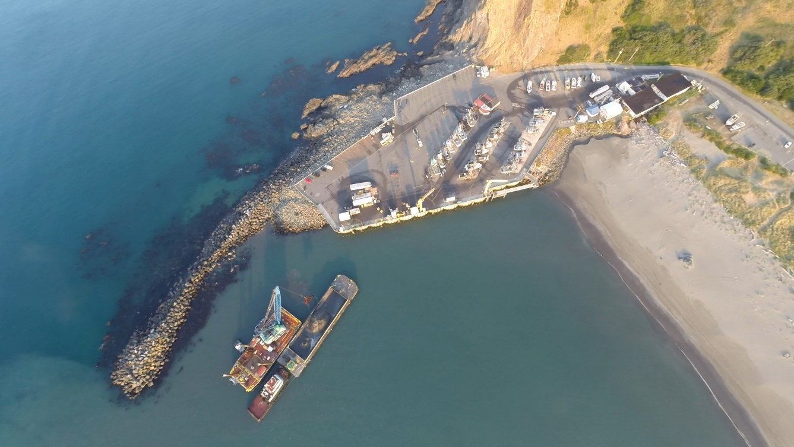

Figure 2. High Dock
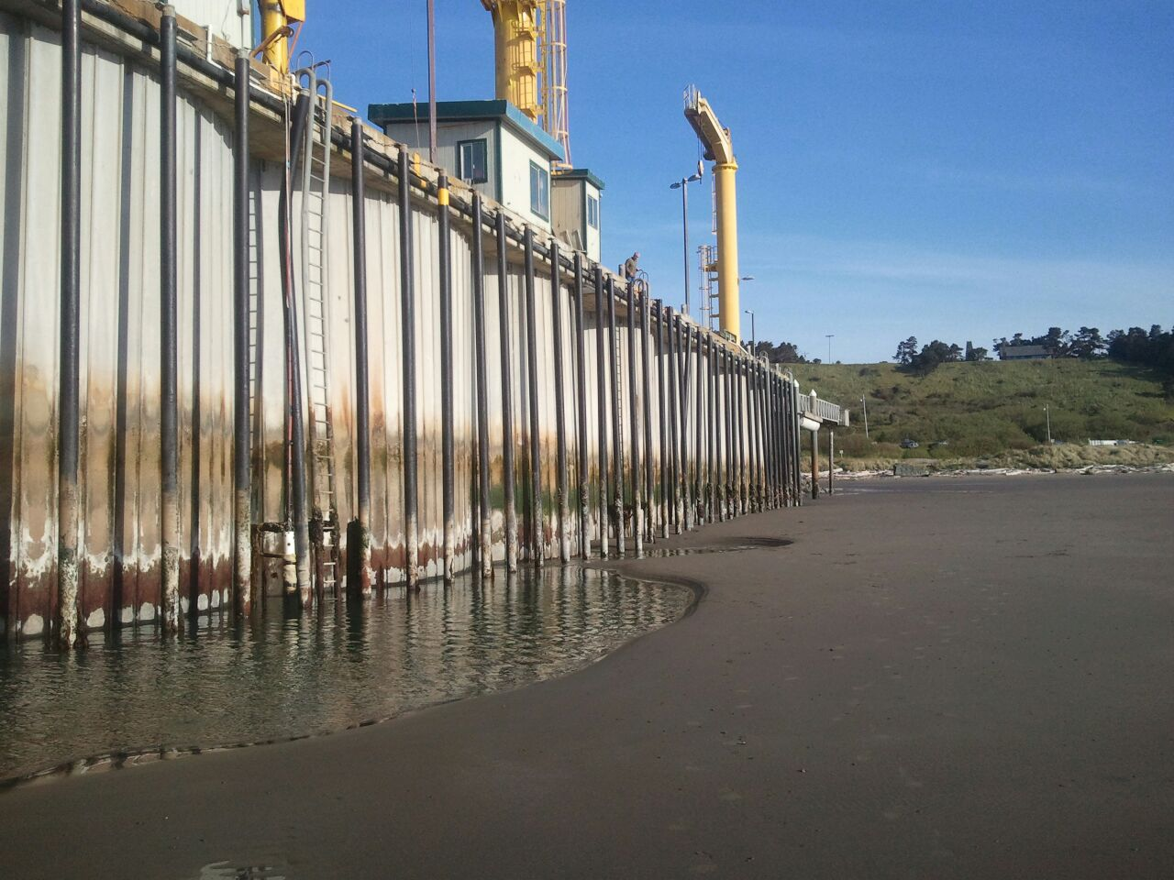
Figure 3. High Dock Cranes
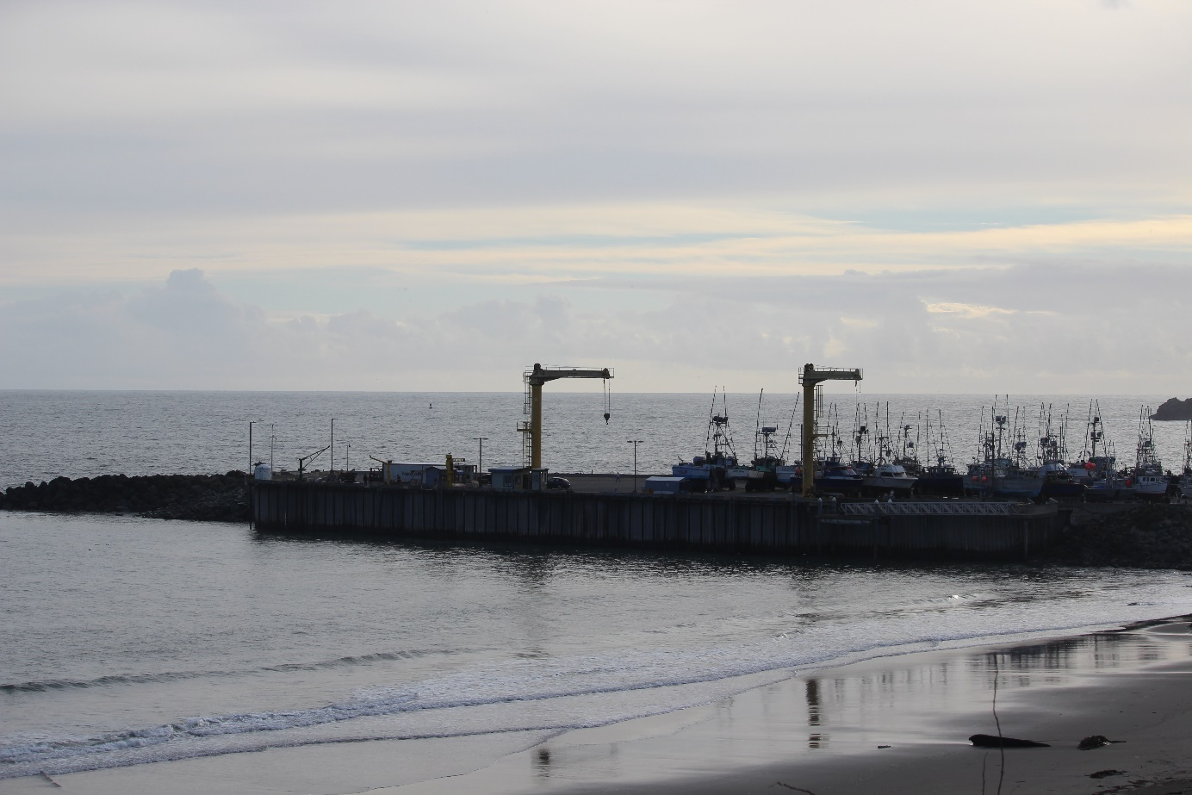

Figure 4. Rock Breakwater
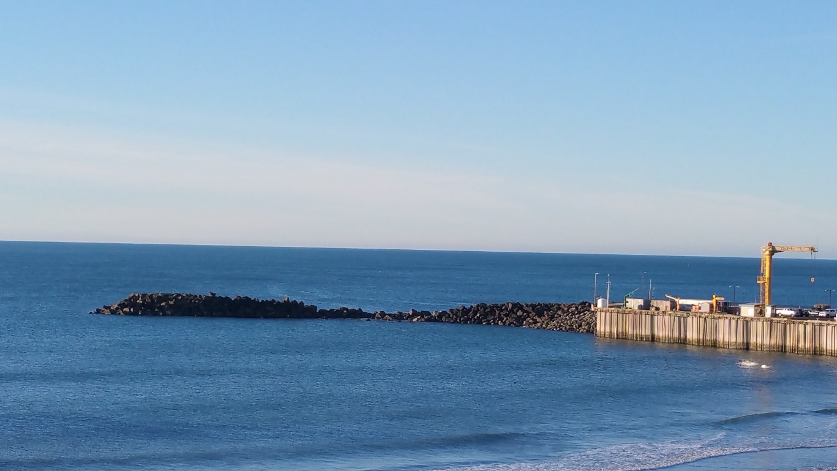
Recreational Dock The Port offers a floating dock at the northeast corner of the facility for recreational users during the summer and fall. A gangway from the high dock provides access to the recreational dock. During the winter and spring, the dock and gangway are removed from the water to prevent
damage from storms.

Cannery Building
The Cannery Building is a two-story structure of wood construction and was built around the
1930s. The building is in poor condition and in need of major repairs. The second floor of the
building is not usable and portions of the concrete floor are caving in. The roof was repaired in 2004. Norcal Seafood is the current tenant on the ground floor. Norcal leases approximately
8,100 square feet and houses live fish tanks in the building.

Port Administrative Offices The Port’s administrative offices are housed in a small metal building at the marina that
includes space for an office, board meetings, storage, and maintenance.

Additional Buildings Additional buildings at the Port include Griff’s Restaurant, public restrooms, and an electrical
building. The electrical building was constructed during the high dock construction in 2002. Theconstruction of the electrical building was faulty and did not include a vapor barrier and
subsequently flooded. The electrical building is located at the base of a large rock bluff where
sloughing is a concern. However, the electrical building has electrical cabinetry for an
additional 9 meters.

Public Street Access Access to the Port is available from Highway 101 (US 101), a principal arterial, and heading
west on Washington Street, which turns into Dock Road. Washington Street and Dock Road are classified as Local Streets in the City of Port Orford’s Transportation System Plan. US 101 had
daily traffic volumes ranging from 4,500 to 7,000 vehicles per day per the 1996 Traffic Volume
Tables provided by Oregon Department of Transportation.

Water
Potable water is supplied by the City of Port Orford.

Wastewater and Sanitary Sewer The sanitary sewer collection system is maintained by the City of Port Orford.

Electrical Power The Coos Curry Electric Cooperative is responsible for supplying power to the high dock.
Communication Telephone service is provided by Frontier Telephone. Cable is provided by Charter Cable.

Stormwater The marina has a trench drain stormwater collection system, with an oil/water separator and
outfall that discharges to the Pacific Ocean.

5TH AND WASHINGTON OPPORTUNITY SITE

Overview
The 5th and Washington site is a 30,000squarefoot (150 by 200 feet) unimproved parcel zoned mixed use. There is a 45 foot height limit imposed on the site with no setback
requirements for future developments. The site has Port and coastal views. The site is flat and iscurrently being used as a viewpoint for the ocean and dock operations. Connections to the
existing utilities are unknown.

REFERENCES
David Evans and Associates Inc. and H. Lee & Associates. City of Port Orford Transportation
System Plan. September 2002.

Leis, Adrian. Crane Study. 2013.

Maritime Consulting International. Port of Port Orford Facility Master Plan. 30 April 2009.

Maritime Consulting International. Port of Port Orford Strategic Business Plan. 01 November 2004.
Oregon Solutions. Port of Port Orford Economic Development Declaration of Cooperation. 22 June 2009.
Peratrovich, Nottingham & Drage, Inc. Port of Port Orford Permanent Dock Structure. June 1999.
Shoji Planning and Development. Port of Port Orford Strategic Business Plan. 01 November 2004.
Port of Port Orford
Strategic Business Plan
Port Orford, Oregon

Appendix D
Financial Plan

Port of Port Orford
Strategic Business Plan
Port Orford, Oregon

Appendix E
Dredge Operational Analysis Summary
Not included--See Office copy

Port of Port Orford
Strategic Business Plan
Port Orford, Oregon

Appendix F
Dredge Financial Analysis
Not included--See Office copy

Port of Port Orford
Strategic Business Plan
Port Orford, Oregon

Appendix G
Submersible Pump Dredging Cost Estimate
(Provided by the Port)

Pending accruals and updates

Port of Port Orford
Strategic Business Plan
Port Orford, Oregon

Appendix H
Cannery Pro Forma Memorandum

History of Port Orford and the Port of Port Orford, http://www.enjoyportorford.com/history.html and http://www.portofportorford.com/history, accessed September 2013.
“Let’s Get Dredged” event organized by Citizens to Keep the Port in Port Orford to show support for dredging the Port, July 4, 2012. (Source: Citizens to Keep the Port in Port in Port Orford)
POORT Mission Statement, http://www.oceanresourceteam.org/, accessed September 2013.
Estimate provided by the Port.
Based on estimates provided by the Port; the other 30 percent of Port revenues are primarily derived from property taxes and commercial building space lease revenues.
The information in this section was provided by FCS GROUP.
Port Orford Breakwater Site Inspection Report, 23 July 2014.
Source: Port of Port Orford.
The Oregon Employment Department defines a green job as one that “provides a service or produces a product in any of the following categories: increasing energy efficiency; producing renewable energy; preventing, reducing or mitigating environmental degradation; cleaning up and restoring the natural environment; providing education, consulting, policy promotion, accreditation, trading and offsets, or similar services supporting categories 1-4.”

