Copyright 2012 by The American Institute of Architects (AIA)
Exclusively published and distributed by Architectural Computer Services, Inc. (ARCOM) for the AIA
SECTION 316329 - DRILLED CONCRETE PIERS AND SHAFTS
RRevise this Section by deleting and inserting text to meet Project-specific requirements.
This Section uses the term "Architect." Change this term to match that used to identify the design professional as defined in the General and Supplementary Conditions.
Verify that Section titles referenced in this Section are correct for this Project's Specifications; Section titles may have changed.
Adhere to 2024 Oregon Standard Specifications for Construction Section 00512 – Drilled Shafts except as modified below.

Revise section 00512.90 as follows:

Pay Item | Unit of Measurement
(a) Furnish Drilling Equipment | Lump Sum
(b) Drilled Shaft Excavation, 9.19 ft Diameter | Foot
(c) Drilled Shaft Concrete | Lump Sum
(d) Drilled Shaft Reinforcement, Grade 80 and Grade 60, as indicated | Lump Sum
(e) CSL Test Access Tubes | Foot
(f) CSL Tests | Each

Revise Table 02001-1 of section 02001.20 as follows:
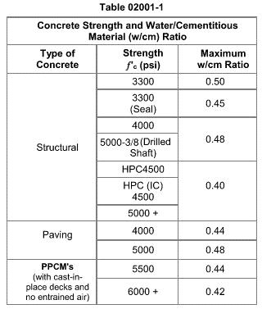

END OF SECTION 316329

