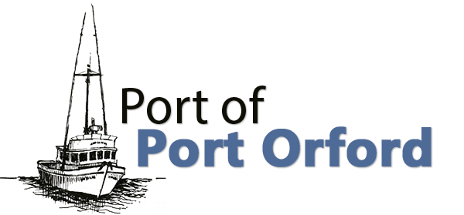

PORT OF PORT ORFORD PORT COMMISSION REDEVELOPMENT WORKSHOP

Agenda
FOR THE REDEVELOPMENT WORKSHOP TO BE HELD ON

WEDNESDAY April 9th, 2025 6-7 PM
Meet at OSU Port Orford Field Station – 444 Jackson St., Port Orford or
Via Teleconference (Google Meet), followed by dock walk:
To join the video meeting, click this link: meet.google.com/nbg-oaga-nyf Otherwise, to join by phone, dial (US) +1 909-929-1590 and enter this PIN: 286 785 775#
To view more phone numbers, click this link: More phone numbers Reasonable efforts will be made to assist and accommodate individuals with a disability.
Please contact Port Administrator Catherine Scobby at (541) 332-7121 to request assistance.

- Call to Order
  - Introductions

- Report
  - Working Waterfront Revitalization Initiative Update – Tom Calvanese, Redevelopment Committee Chair

- Action or Discussion Items/New Business (Recommendations to Commission may occur)
  - Review maps and discuss product hoist placement and type before dock walk

- Dock Walk – head to the Port to walk the working edge of the dock and consider hoist placements and other logistics discussed earlier

- Future Agenda Items

- Adjournment

