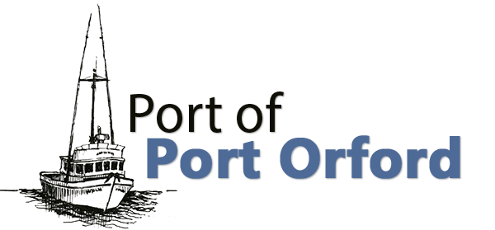

PORT OF PORT ORFORD PORT COMMISSION REDEVELOPMENT WORKSHOP

Agenda
FOR THE REDEVELOPMENT WORKSHOP TO BE HELD ON

THURSDAY MAY 15th, 2025 6-7 PM
Meet at OSU Port Orford Field Station – 444 Jackson St., Port Orford or
Via Teleconference (Google Meet)
To join the video meeting, click this link: meet.google.com/nbg-oaga-nyf Otherwise, to join by phone, dial (US) +1 909-929-1590 and enter this PIN: 286 785 775#
To view more phone numbers, click this link: More phone numbers Reasonable efforts will be made to assist and accommodate individuals with a disability.
Please contact Port Administrator Catherine Scobby at (541) 332-7121 to request assistance.

- Call to Order
  - Introductions

- Report
  - Working Waterfront Revitalization Initiative Updates – Tom Calvanese, Redevelopment Committee Chair

- Action or Discussion Items/New Business (Recommendations to Commission may occur)
  - Product hoist discussion – types, placement, operations

- Future Agenda Items

- Adjournment

