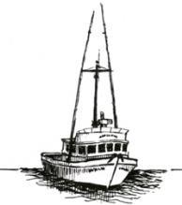

PORT OF PORT ORFORD PORT COMMISSION

SPECIAL MEETING

Agenda

FOR THE SPECIAL MEETING TO BE HELD ON
Friday, August 29, 2025 @ 6:00 PM
Port Orford City Hall - 555 20th St. & Via Teleconference (Googlemeet):

Special Meeting of the Port of Port Orford
Time zone: America/Los_Angeles
Google Meet joining info
Video Call Link: meet.google.com/rte-hkxq-gfz
Or dial:(US) +1 650-667-3034
Pin: 216 179 905#

Reasonable efforts will be made to assist and accommodate individuals with a disability.
Please contact Port Administrator, Catherine Scobby at (541) 332-7121 to request assistance.

- Call to Order

- Roll Call
- Declaration of potential conflicts of interest

- Action or Discussion Items (Action May Occur)

- Crane Replacement Project - Change Order Proposal (COP 004) – Electrical Update 8.15.25
- Schedule for relocation of NorCal and Hallmark product/utility hoists

- Adjournment and Confirmation of Next Meeting – September 16, 2025

