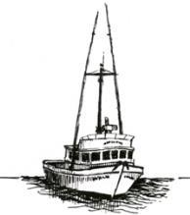

PORT OF PORT ORFORD PORT COMMISSION

REDEVELOPMENT COMMITTEE WORKSHOP

Agenda

FOR THE REDEVELOPMENT WORKSHOP TO BE HELD ON
Tuesday, August 12th, 2025 @ 6:00 PM – 7:00 PM
OSU Field Station, 444 Jackson St, Port Orford & Via Teleconference (Googlemeet):

Redevelopment Committee Workshop for the Port of Port Orford
Time zone: America/Vancouver
Google Meet joining info
Video call link: https://meet.google.com/nbg-oaga-nyf
Or dial: (US) +1 909-929-1590‬ PIN: 286 785 775‬#‬‬‬‬
More phone numbers: https://tel.meet/nbg-oaga-nyf pin=3823847482726

Reasonable efforts will be made to assist and accommodate individuals with a disability.
Please contact Port Administrator, Catherine Scobby at (541) 332-7121 to request assistance.

- Convene Redevelopment Workshop - Chair, Tom Calvanese

- Working Waterfront Revitalization Program Brief Update

- Site Planning 2.0 - discussion (Recommendations May Occur)
- Ice Supply – discussion (Recommendation May Occur)

- Adjournment and Confirmation of Next Meeting – September 2, 2025

